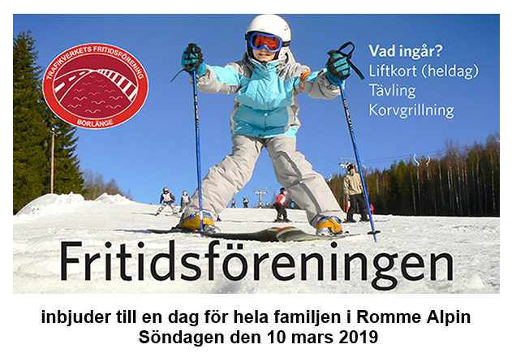

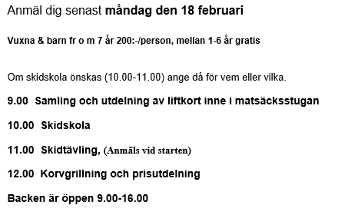

Mer information och anmälan hittar du [här](https://app.emarketeer.com/ext/form/survey.php?m=286897a2317dd7189019901401327afeb432080&sessid=v1--dublLwOc9FVJeNeMWwDnqCvtmPJYBl4&page=1)